**DAILY ONLINE ACTIVITIES SUMMARY**

|  |  |  |  |  |  |  |  |  |
| --- | --- | --- | --- | --- | --- | --- | --- | --- |
| **Date:** | **17/06/2020** | | | | | **Name:** | **ROHAN VASHISTA BM** | |
| **Sem & Sec** | **6th & B sec** | | | | | **USN:** | **4AL17CS078** | |
| **Online Test Summary** | | | | | | | | |
| **Subject** | | **Programming in C (Workshop quiz)** | | | | | | |
| **Max. Marks** | | **15** | | **Score** | | | **12** | |
| **Pre-Placement Training Summary** | | | | | | | | |
| **Pre placement training** | **9:00 am to 11:00 am - Programming in C**  **11:00 am to 1:00pm - Applications of python in DA and ML** | | | | | | | |
| **Faculty** | | | **Mr.Vivek Sharma**  **Dr. Mohideen Badusha** | | **Duration** | | | **4 hr** |
| **Assessments** | | | | | | | | |
| **Problem Statement:**   1. Examples and Exercises on python. | | | | | | | | |
| **Status: Completed** | | | | | | | | |
| **Uploaded the report in Github** | | | | | **Yes** | | | |
| **If yes Repository name** | | | | | <https://github.com/Rohanvasista/Applications-of-Python-in-DA-and-ML> | | | |
| **Uploaded the report in slack** | | | | | **Yes** | | | |

**C-OPERATORS (Workshop quiz):**

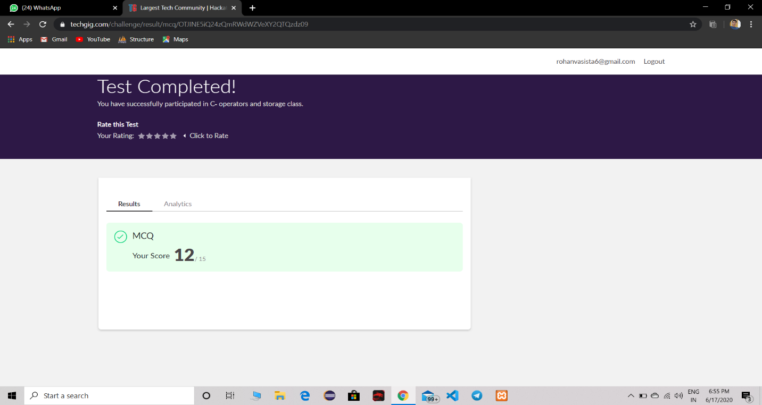

**Training snapshots:**

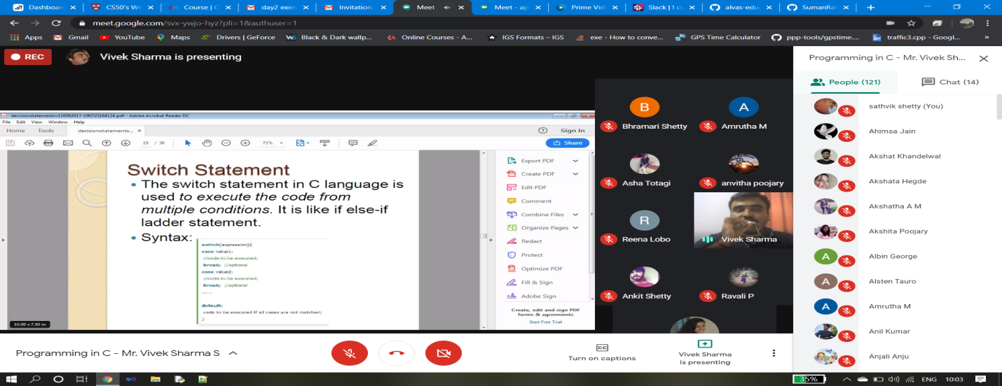

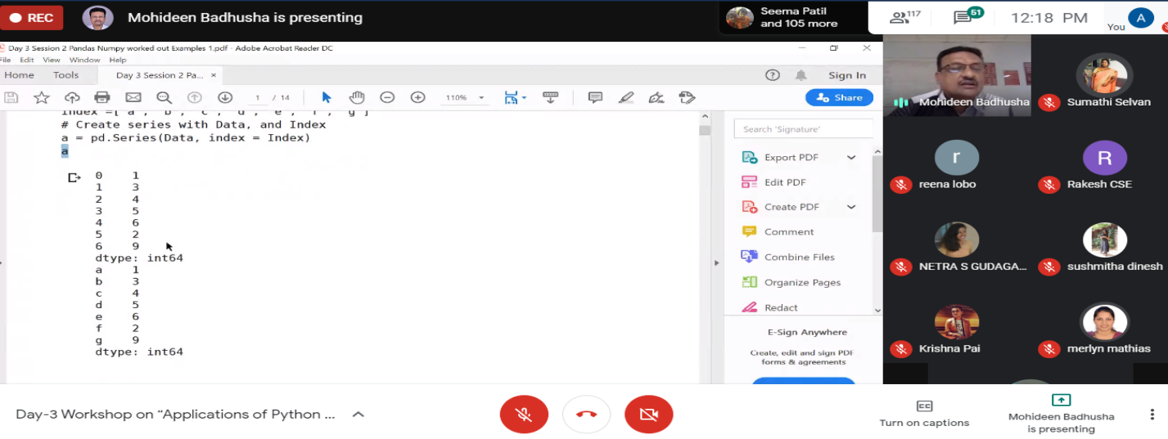

**Assessments:**

**Uploaded in Github account and respective link is provided below.**

<https://github.com/Rohanvasista/Applications-of-Python-in-DA-and-ML>